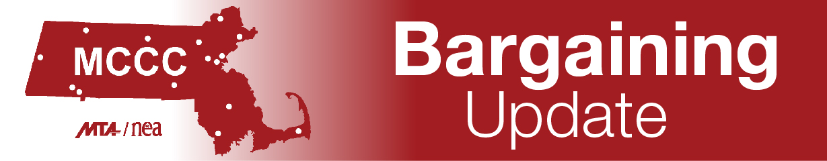
As of-11-17-21
Hello MCCC Day Unit Members:
Since we last sent a formal update, the Day Negotiations Team has presented many proposals to management. These proposals include language about office hours, the expansion of parental leave, and anti-bullying language. Although we are not meeting often with management, the negotiations team has been meeting regularly. Between October 1 and Thanksgiving, there will have been at least 11 meetings (3-4 hours each) of the whole team and/or smaller group meetings.
We last met with management on November 10. We presented proposals to ensure that there are health and safety committees on each campus and that each committee has MCCC representation. The proposal also seeks regular distribution and updating of campus safety protocols. We heard from our unit members loud and clear that safety issues were a priority for the negotiations team. In addition, we have asked that the colleges pay the mandatory payroll contributions for medical and family leave under the state Paid Family and Medical Leave Act for all MCCC Day unit members. And, we have asked that we not be required to use all our sick leave prior to eligibility for PFML. We are paying a tax for a benefit that we may never be eligible to use, and it is essentially a pay cut. Lastly, we proposed language on dual enrollment and early college. We have asked for copies of all current agreements, a set of common definitions, MCCC participation in negotiations to create new agreements, notification to faculty of all students under the age of 18, and language that clarifies all community college credit courses are MCCC unit work. Management asked many questions about these proposals but did not formally respond to any of them to date. We plan to ask for additional language that addresses professional staff concerns about early college and dual enrollment.
We continue to work on proposals that address concerns around such issues as sabbatical leave, professional development funds, reassigned time, and grant funded faculty and staff in addition to improvements to the salary grids and new part-time salary grids.
Management has proposals that include the elimination of the day after Thanksgiving as an off-campus professional day. We recognize how contentious this issue is, we have seen this language before, and continue to fight back against this proposal. The colleges would also like to mandate the use of LMS (learning management systems) by faculty and the use of advising software for both faculty and professional staff. The colleges also want data collection from advisement software and assessment embedded into the workload article for faculty and professional staff. And management wants language that would prohibit any other employment during the regular workday for faculty with the exception of DCE courses.
We have many questions and concerns over these proposals and strongly encourage you to remain attentive to bargaining updates and any communications from the CAT (Contract Action Team). If your chapter does not currently have a CAT representative, please help to find a volunteer, and reach out to Colleen Fitzpatrick for assistance at cfitzpatrick@massteacher.org.
We will meet again with management on December 15. This will be the fifth meeting where the two teams can present new proposals. That leaves one additional meeting to present new proposals. Please understand that this does not preclude the teams from presenting counter offers beyond the 6th meeting.
As we are striving as a team to provide contractual information to our MCCC unit members along with our negotiation updates, the Team also wants to remind professional staff unit members that the April 2021 MOA extends the effective date for the cap on professional staff vacation. https://mccc-union.org/wp-content/uploads/sites/69/2021/04/Signed-MCCC-Day-MOA-Extension-on-Vacation-Cap.pdf
If you have any questions about Day negotiations, please do not hesitate to ask us.
In solidarity,
Claudine Barnes
Chair, Day Negotiations Team

